Getting started in business
Forms of Organization
There are many different types of organizations in our society. They can be categorized as Business Entities and Non Business Entities. Business entities generally are organized to earn a profit, whereas non business entities generally exist to serve various segments of society. Both types are summarized in Exhibit 1.1
Exhibit 1.1: Forms of Organization
Business Entities | Non Business Entities
Sole Proprietorships | Government Entities
Partnerships | ( Federal Government and its Agencies and State and Local Governments and their Agencies)
Corporations | Private Organizations
 | (Hospitals, Universities, Cooperatives)
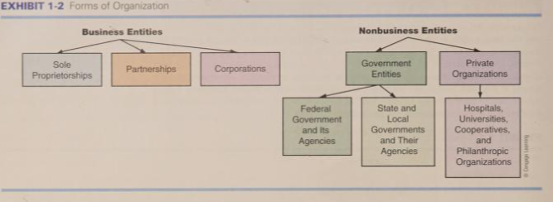
Business Entities:
Business Entities are organized to earn a profit. Legally, a profit-oriented company is one of three types: Sole proprietorships, partnerships, and corporations.
Sole Proprietorships: This form of organization is characterized by a single owner. Many small businesses are organized as sole proprietorships. Very often the business is owned and operated by the same person. Because of the close relationship between the owner and the business, the affairs of the two must be kept separate. This is one example in accounting of the economic entity concept, which requires separation of personal costs from the cost associated with the business. In turn, financial statements prepared for the business must not intermingle the owner’s personal affairs with the affairs of the business. (Define Business Entity concept or Economic Entity concept)
Partnerships: A partnership is a business owned by two or more individuals. When two partners start doing business, they need some sort of agreement as to how much each would contribute to the business and how they would divide any profits. In many small partnerships, the agreement is often just an oral understanding between the partners. In large businesses, the partnership agreement is formalized in a written document.
Corporations: A corporation is an entity organized under the laws of a particular state. To start a Corporation, one must file articles of incorporation with the state. If the articles are approved by the state, a corporate charter is issued, (A corporate charter is a document filed with the Secretary of State or registrar to establish a company as a corporation.) and the corporation can issue stock. A share of stock is a certificate that acts as evidence of ownership in a corporation. Stocks of many corporations are traded on organized stock exchanges such as Nepal Stock Exchange Ltd.
What are the advantages of running a business as a corporation rather than a partnership?
- One of the primary advantages of the corporate form of organization is the ability to raise large amounts of money in a relatively brief period of time. To raise money, corporations can sell different types of securities: Stocks and bonds. As stated earlier, a share of stock is simply a certificate that evidences ownership in a corporation. A bond is similar in that it is a certificate or piece of paper issued to someone. However, it is different from a share of stock in that a bond represents a promise by the company to repay a certain amount of money at a future date. Interest on bonds is paid annually or semiannually. (More about bonds and stocks will be discussed under financing activities later)
- The ease of transfer of ownership in a corporation is another advantage of this form of organization. If you hold shares of stock in a corporation, it can be easily traded in the stock market.
- Another distinct advantage is the limited liability of the stockholder. Generally speaking, a stockholder is liable only for the amount contributed to the business. On the other hand, both proprietors and general partners usually can be held personally liable for the debts of the business.
Non Business Entities
Most non-business entities are organized for a purpose other than to earn profit. They exist to serve the needs of various segments of society. For example Lumbini Provincial Hospital is organized to provide health care to its patients. A Municipal corporation is operated for the benefit of its citizens.
All these entities are distinguished by the lack of an identifiable owner. The lack of an identifiable owner and of the profit motive changes to some extent the type of accounting used by nonbusiness entities.

The Nature of Business Activity
The different activities of a corporation can be categorized into three types: Financing, investing and operating.
Financing Activities: All businesses must start with financing. We can simply say, money is needed to start a business. Accounting has its own unique terminology; In fact, accounting is often referred to as the language of business. The discussion of financing activities brings up two important accounting terms: Liabilities and Capital Stock.
A liability is an obligation of a business; it can take many different forms. When a company borrows money at a bank, the liability is called a note payable. When a company sells bonds the obligation is termed as bonds payable. Amount owed to the government for taxes are called taxes payable. When company purchases on credit from suppliers that obligation is termed as Account Payable.
Capital Stock is the term used by accountants to indicate the dollar amount of stock sold to the public. Capital stock differs from liabilities as those who buy stock in a corporation are not lending money to the business like Bank, bondholders. Someone who buys stock in a company is a stockholder and that person is providing a permanent source of financing to the business. In other words there is no due date at which the stockholder will be repaid. Normally the only way for a stockholder to get back his investment is by selling it to someone else.
Please note someone who buys bonds or in some other way makes a loan to the company is called a creditor. A creditor does not provide permanent source of financing to the business. That is the creditors expect repayment of the amount loaned and, in many instances, payment of interest for the use of money as well.
Investing Activities: There is a natural progression in a business from financing activities to investing activities. That is, once funds are generated from creditors and stockholders, money is available to invest. The cash obtained from financing activity is invested by the business in Assets.
An asset is any resource owned or controlled by a business. Asset represents value of ownership that can be converted into cash. (Although cash itself is considered an asset). Company owned buildings and equipments are asset to it. At any point of time in a company there is stock of raw materials and finished product. The finished products and raw materials are called inventory and are another valuable asset for a company.
Accounts Receivable: When a company sells products or services on credit, it obtains the right to collect the amount due from the customer which is an asset called Accounts Receivable.
Operating Activities: Once funds are obtained from financing and investments are made in productive assets, a business is ready to begin operations. Every business is organized with a purpose to sell products or services.
Revenue is the inflow of assets resulting from the sale of products and services. When a company makes a cash sale, the asset received is cash. When a sale is made on credit, the asset received is an account receivable. Now you should understand that revenue represents the dollar amount of sales of product and services for a specified period of time.
Sale of products or services is one important operating activity. However costs must be incurred to operate a business. Employees must be paid salaries, suppliers must be paid for purchase of inventory and other utility expenses must be paid. All of these are examples of important operating activities of a business which results in outflow of assets. Expense is a specific name used for the cost incurred in operating a business.
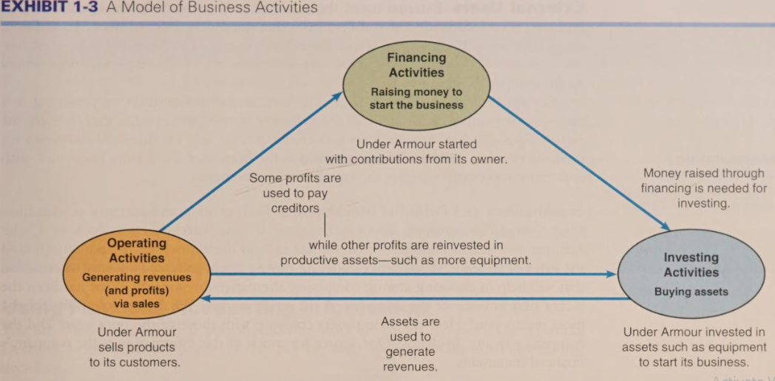
What is Accounting, and what information do Users of Accounting reports need?
Accounting is “the process of identifying, measuring and communicating economic information to permit informed judgments and decisions by users of the information”
Users of Accounting Information and Their Needs:
It is helpful to categorize users of accounting information on the basis of their relationship to the organization. i.e. internal and external users.
Internal Users: Internal users are individual who actively participate in management and operation of regular activities of the organization. They involve owners, board of directors, managers,
employees. The management of a company is in a position to obtain financial information in a way that best suits its needs. For example if management wants to find out if the monthly expenses are more or less than budgeted amount then a report can be generated to provide the answer. Management accounting is the branch of accounting concerned with providing internal users( management) information to facilitate planning and control.
- Owners: In sole proprietorship and partnership owners are directly involved in day to day business activities, they use accounting information to make business related decisions.
- Board of Directors: The members of board of directors are the representatives of shareholders who are responsible for day to day business activities of the company. For taking business related decisions they need accounting information.
- Managers: Managers need accounting information for planning, monitoring and taking business related decisions.

External Users: External users are not directly involved in the operation of a business. They must rely on the information presented to them by the management of the company. Financial accounting is the branch of accounting concerned with communications with outsiders through financial statements.
- Stockholders and potential stockholders: Both existing and potential needs financial information about a business. If you currently own a stock in a company, you need information that will aid in your decision either to continue to hold the stock or to sell it. If you are considering buying stock in a company, you need financial information provided in financial statements to choose among alternative investments.
- Bondholders, Bankers: Before buying a bond in a company we are concerned about whether the company will be able to repay the principal at maturity date and also the regular interest payments. To decide on that financial statement helps us. Similarly before lending money a bank will study the financial statement of a company to decide on the company’s ability to repay the loan and interest.
- Government Agencies: Government agencies need financial information of any company to impose tax, regulate the activities etc. Therefore Income tax authorities are interested in profit.
- Trade Creditors: Trade creditors supply raw material and other goods on credit to the company. They use the accounting information to decide on whether the company will be able to pay their short term debts on time.

Generally Accepted Accounting Principles (GAAP): it refers to the various methods, rules, practices commonly followed for accounting and financial reporting. GAAP acts as a guide for accountants on how to report the economic activities of a business. The purpose of GAAP is to ensure that financial reporting is transparent and consistent from one organization to another.
Basic Accounting Assumptions, Principles and Conventions:
Accounting Concepts/Assumptions:
- Business Entity Assumption: According to this assumption, the business and the owner are said to have distinct identities and therefore the personal affairs of the owner should not be mixed with the business transaction.
- Going Concern Assumption: While recording business transactions in the books of accounts, it should be assumed that business will be carried on for a long period of time. As a result of this assumption the fixed assets are recorded in cost less depreciation and not in market value.
- Money Measurement Assumption: According to this assumption, accounting should record facts and events that can be expressed in terms of money i.e. only financial transaction should be recorded in accounting and non financial transactions are not recorded in accounting.
- Accounting Period Assumptions: This principle basically focuses on maintaining books of account for specific period, e.g. for a year. It is known as financial period. In context to Nepal accounting period is from first Shrawan to Asadh last. To measure the performance of a business accounting periods are needed as the life of the business is indefinite.

Accounting Principles:
- Revenue Realization Principle: under this principle, only those revenues and incomes, which have been realized either in cash or in some valuable consideration or resulted in some legal obligation, are recorded. No sale can be said to have taken place unless it is realized in money or money’s worth or at least some obligation to pay is assumed by the customer.

- Cost Principle: The cost principle requires that accountants record assets at the cost paid to acquire them and continue to show this amount on the balance sheet until the company disposes them. The term Historical cost is used to refer to the original cost of an asset. This principle does not stop us from charging depreciation to assets.
- Matching Principle: This concept requires that expense of a particular period must be deducted from the Revenue of the same period. The application of matching principle enables us to find correct operating result of the business for a particular period.
- Duality Concept: This principle states that every transaction has a two-fold effect which is recorded as Debit and Credit.
Accounting Conventions:
- Conservatism: This convention is based on the principle that management needs to anticipate no profit, but provide for all possible losses. This convention clearly states that profit should not be recorded until it is realized but anticipated losses should be provided for.
- Consistency: This convention requires businesses to consistently follow same accounting procedures while preparing financial statement year after year to ensure comparability of the Statements for making decisions.
- Materiality: The convention of materiality states that only relevant information should be supplied to the users of accounting information.

Branches of Accounting:
Financial Accounting: This branch of accounting deals with recording, classifying and summarizing financial activities and presenting them to the related stakeholders like management, shareholders, government, investors etc. It is an information system which measures, processes and communicates financial information to decision makers. Targeted users of financial information are external users who want fairness in the financial statements and financial accounting ensures the same.
Cost Accounting: Cost accounting deals with providing detailed information of cost associated with products, operation, process, jobs. The reports prepared under cost accounting are targeted to internal users, management of the company. The purpose is to ensure planning and apply effective control to achieve cost reduction.
Management Accounting: This branch of accounting exists to assist the management is the decision making process. It uses the data provided by both financial and cost accounting and prepares reports intended for the use by the management.

Qualitative characteristics of accounting information:
Accounting Information must be useful for decision making. What makes the accounting information useful? The qualities or characteristics which make accounting information useful are as follows:
- Understandability: for anything to be useful it must be understandable, therefore accounting information must be presented in an understandable way.
- Relevance: To be useful information must be relevant. Relevance is the capacity of the information to make a difference in a decision.
- Reliability: It implies that the information presented in financial statement should be fair and verifiable. For a information to be reliable it must possess the following characteristics:
- Timeliness: for accounting information to be relevant it must be timely.
- Verifiability: Information to be relevant must be verifiable.
- Neutrality: Information is neutral when it is free from biasness, i.e. it portrays the company’s position the way it is.
- Comparability: Accounting information must ensure comparability by following same set of accounting policies and procedures.
- Materiality: Immaterial things which have no relevance in decision making can be avoided. Also we can say only material information must be presented in accounting information.
Accounting Professions:
Accounting is a broad term that incorporates a large number of different accounting works in the organization. Every business has scope for accounting work which is carried out by accounting professionals. Like every other profession accounting also has its own scope. Different types of accounting job performed by accountant are as follows:
Financial Accountant: Financial accountant are responsible to prepare financial statements of a company. It includes the accounting process of recording, summarizing, measuring the performance of a business by preparing financial statement.
Cost Accountant: They provide detailed information of cost associated with products, operation, process, jobs to ensure planning and control to achieve cost reduction.
Internal Auditor: They are responsible for checking and verifying the accuracy of the accounting work to make the reliable for the users.
Management Accountant: They are responsible for collecting the data provided by financial and cost accounting and present them to the management as per their needs to assist in decision making process. Management accountant has a wide scope of jobs as they need to assist in planning and controlling by providing relevant information to the management.

Accounting Information system in modern business organizations and use of computers in accounting
With the increase in use of computers the accounting information system has been also computerized. Today there are Accounting software’s which are designed specifically as per the nature of the business. Accounting software’s makes the performance measuring job easier and this is also one of the reasons of its popularity. Accounting software are designed in such a way that different kinds of reports can be generated at one click whenever needed, this feature helps the management with timely information for decision making. It also saves time as most of the reports are automatically generated by the software. Routine entry job in the software does not require high accounting skills which makes it more popular.
- What is Financial Accounting?
- What do you mean by GAAP?
- What is Business Entity concept of Accounting?
- What are the qualitative characteristics of Accounting information? Explain
- Users of accounting information. Explain
- Describe the features of a corporation.
- What does going concern mean?
- What do you mean by accounting period concept?
- Explain the need for accounting information to different internal and external users of accounting information.
- List out different types of assets

